Payeer for CMS Wordpress 4.7.2 – Easy Digital Downloads 2.7.4

In admin panel go to “Plugins -> Add new”.
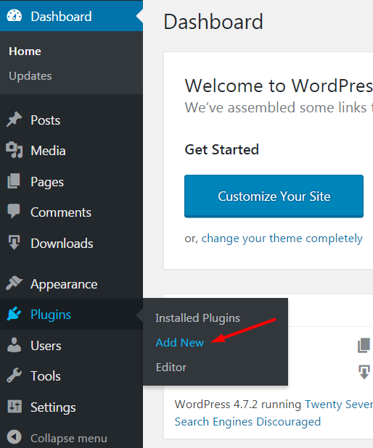

Click “Upload Plugin”.
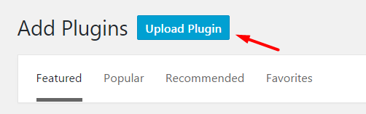

Select the archive edd-payeer.zip and click “Install Now”.
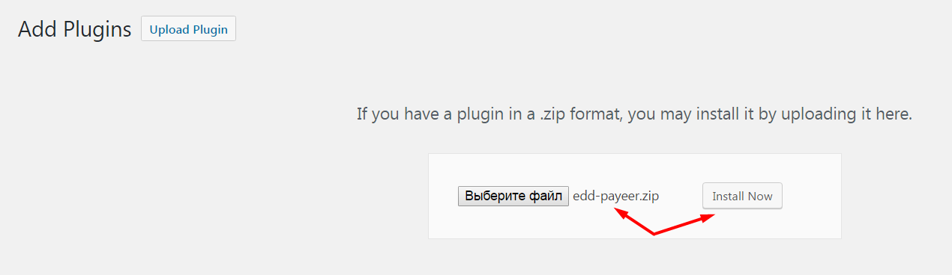

After successful installation, activate the plugin.
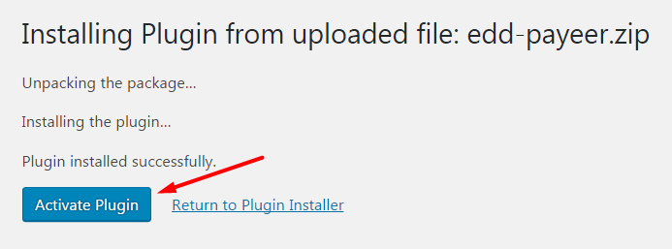

In the list of installed plugins, you should see the newly installed module Payeer.
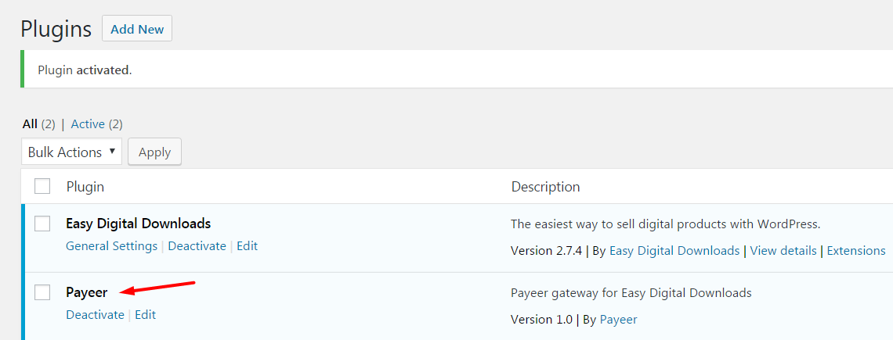

Open the settings of the plugin Easy Digital Downloads by going to “Downloads -> Settings”.
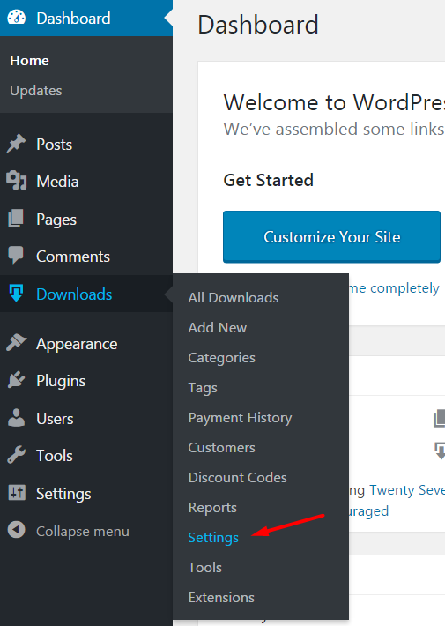
Open the tab “Payment Gateways" and activate Payeer, specify the default gateway Payeer.
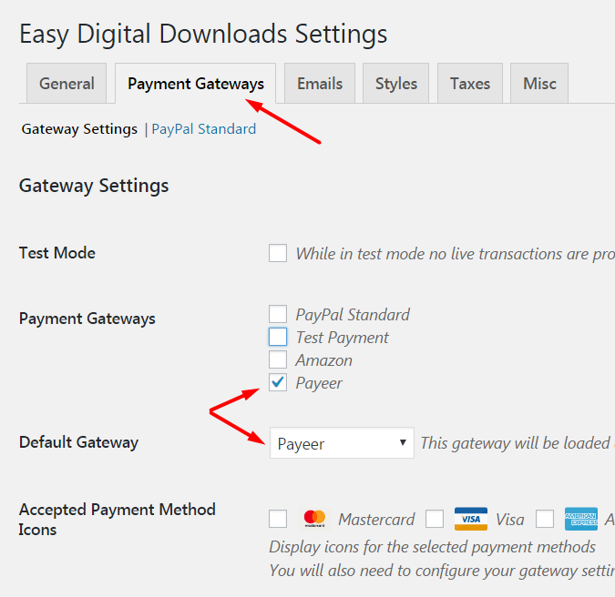

Below are the payment gateways specify the settings of the payment system Payeer.
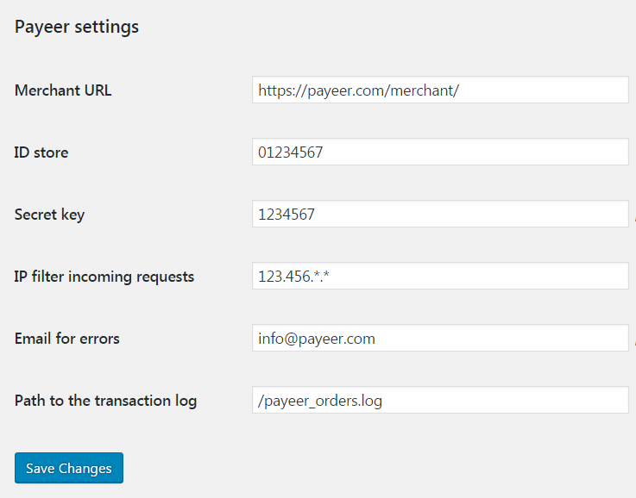

Merchant URL: the default path to the payment https://payeer.com/merchant/
ID store: id of your store in the system Payeer.com (can be found in the personal cabinet).
Secret key: the secret key of your store, also issued to you when registering in the system.
Path to the transaction log: if you specify the path to the file logging, you will be recording information about payments via Payeer.
IP filter: You can specify the list of all trusted ip addresses of servers, separated by commas. You can also specify a mask instead of the ip address. If the field is empty, checking for trusted ip addresses is not performed.
For example:
192.168.71.87, 192.165.83.17, 192.178.34.15
Or 192.*.71.87, 192.165.83.*, 192.*.34.15
Or *.*.*.* - all available ip addresses

Email for errors: enter your email address to receive notices in the event of an error of payment. The letter will state the reason and basic information about the payment.
Click "Save Changes".
On the website payeer.com in the dashboard, enter the URL in the store settings.
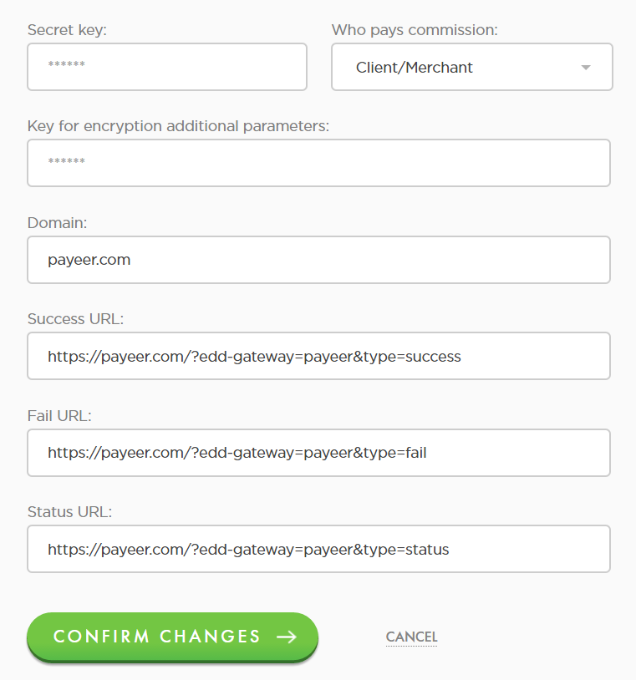

Success URL
http:// *****/?edd-gateway=payeer&type=success
Fail URL
http:// *****/?edd-gateway=payeer&type=fail
Status URL
http:// *****/?edd-gateway=payeer&type=status
Where ***** is your domain.
Confirm changes.
Module Payeer for CMS Wordpress 4.7.2 – Easy Digital Downloads 2.7.4 configured.

